

Programme Name: ________**BCS HONS**_______________________________________

Course Code: __**CSC 2330** _______

Course Name: ___**Software Project Management**_____ ______________________________

**Assignment** / Lab Sheet/ Project / Case Study No. _**2**___

Date of Submission: _____**2021/1/4**_____________

**Submitted By: Submitted To:**

Student Name**: Dipesh Tha Shrestha** Faculty Name**:** **Satyam Paudel**

IUKL ID: **041902900028** Department**: LMS**

Semester**: Third Semester**

Intake**: September 2019**

1. **Describe scrum framework in detail with the help of a diagram.**

Scrum is not just a process which provides a series of sequences that will help you to produce a high-quality product on time and within a budget. Rather, Scrum is a process framework that allows addressing complex problems to deliver products of the highest possible value. At the beginning of 1990, when Scrum was in its infancy, organizations started using the Scrum framework to build the products using various processes and techniques.

Basically, Scrum is an easy, people-centric framework based on the values of:

* Commitment
* Openness
* Courage
* Respect
* Focus

The Scrum framework consists of the Scrum teams with associated Scrum Roles, Scrum Ceremonies, Scrum Artifacts, and Scrum rules. Each component within a Scrum framework has specific grounds and is a key factor to Scrum’s success, whereas the Scrum rules tie the ceremonies, roles, and artifacts together to govern the relationships between them.

Scrum Framework consists of three Scrum Roles-

* Product Owner
* Scrum Master
* Development team

The Product Owner (PO) mainly concentrates on maximizing the value of the product and the teamwork. The entire organization respects PO’s decisions. The PO is the only person who manages the Product Backlog. This includes:

* Mentioning Product Backlog items clearly.
* Prioritizing the Product Backlog items to achieve project goals.
* Optimizing the value of the teamwork.
* Ensuring the Product Backlog is transparent to all.
* Ensuring that the team understands the Product Backlog items.

The Scrum Master is a Servant leader of the Scrum team. He or she guides the team and the Product Owner ensures that the team members are implementing all the Agile practices properly. The Scrum Master is not only responsible for addressing all the issues encountered in the Agile development process, but also helps the business, product owner, team, and individuals to achieve a target.  
  
The Development team in Scrum is cross-functional, a collection of people who can define, build, and test the required product. The development team size is of 5-9 people and must have all the skills required to produce good quality software. The Development team is a self-organized team that determines the best way to reach out to a solution during product development.

Diagram of Scrum framework;

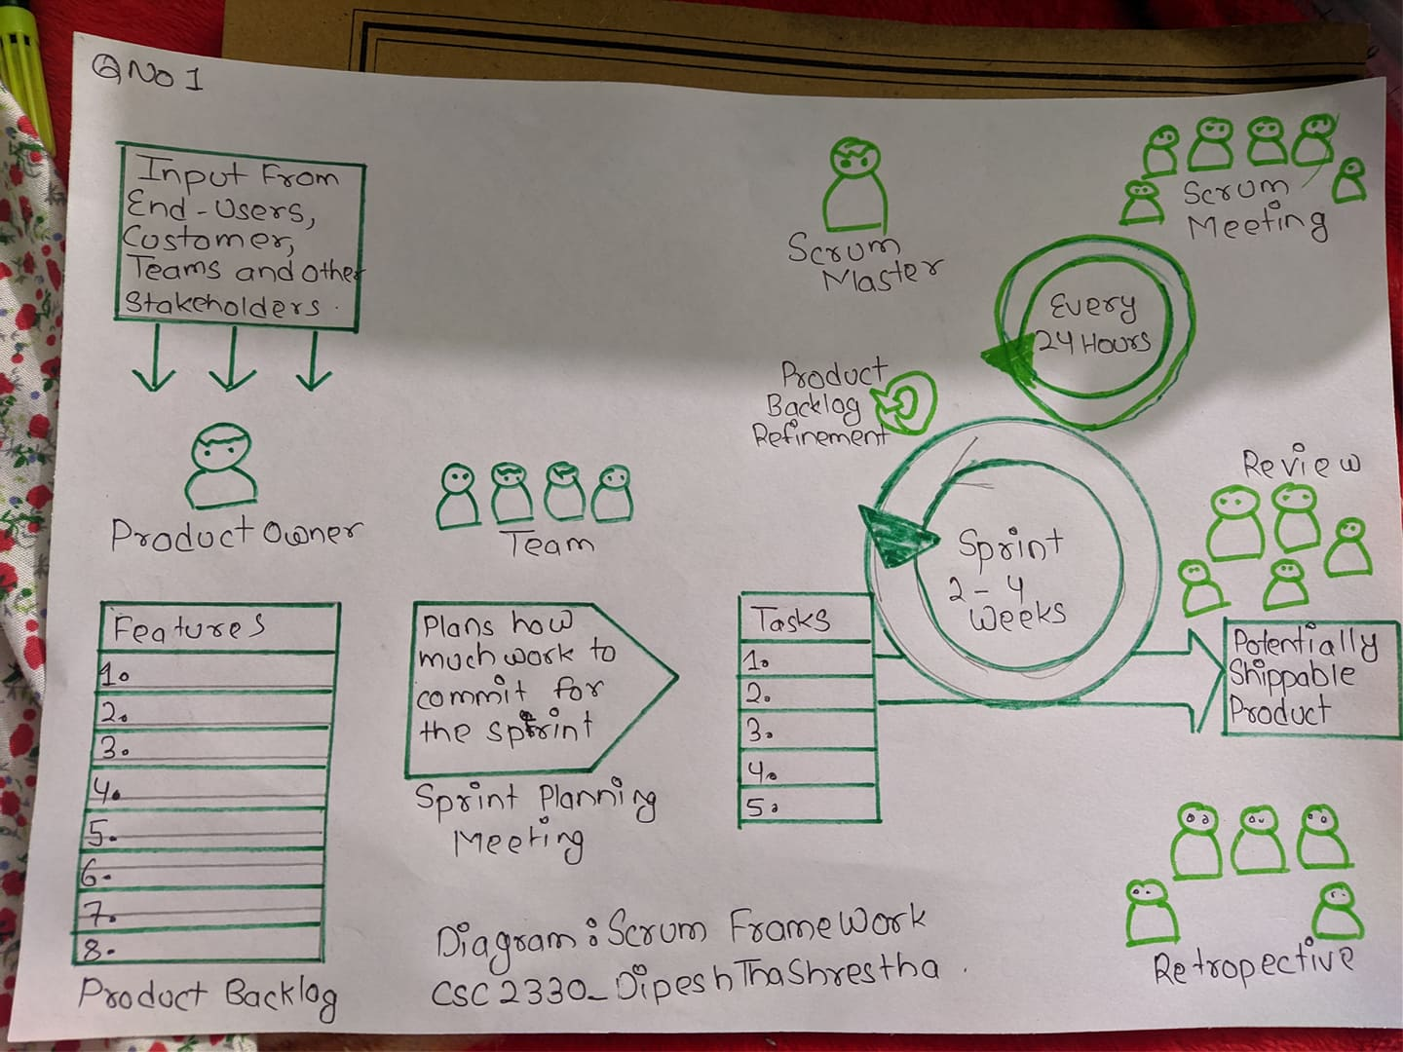

1. **Perform a financial analysis of a project assuming that the projected costs and benefits for this project are spread over four years as follows:**

**Estimated costs are $200,000 in Year 1 and $30,000 each year in Years 2,3 and 4.**

**Estimated benefits are $0 in year 1 and $100,000 each year in Years 2,3 and 4. Use a 9 percentage discount rate, round the discount factors to two decimal places. Create a table of financial template on the paper to calculate and clearly display the NPV, ROI and year in which payback occurs with the**

**help of a graph. In addition, write a paragraph explaining whether you would recommend investing in this project, based on your financial analysis.**

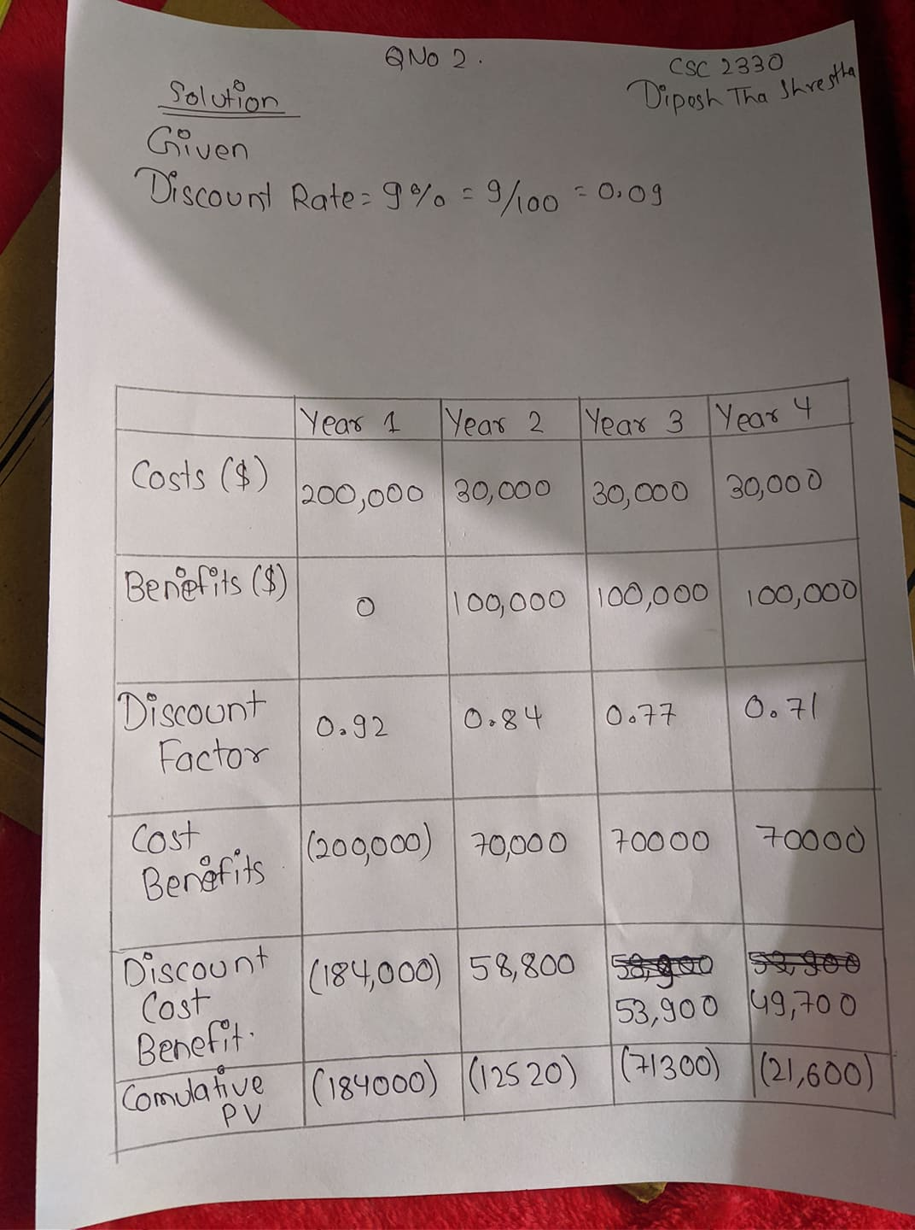

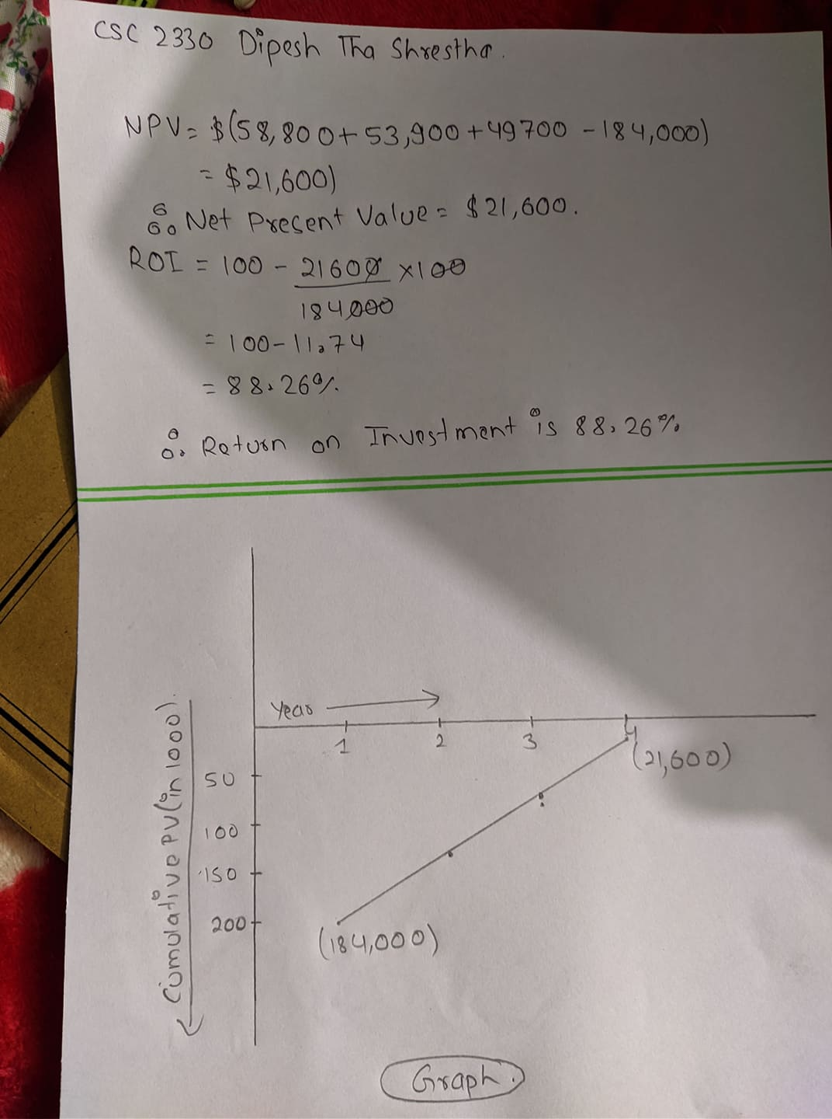

1. **Assume that you have completed six months of the project. The BAC was $400,000 for the six-month project.**

**PV= $220,000**

**EV= $200,000**

**AC= $180,000**

* 1. **Calculate Cost variance.**

**Answer:** cost variance (cv)= ev - ac

= 200000-180000

= $20,000

* 1. **Calculate Schedule variance for the project**

Answer: schedule variance(sv) = ev - pv

= 200000 – 220000

= - $20,000

* 1. **Calculate the Cost Performance Index**

Answer: cost performance index(cpi) = ev\ac

= 200000\180000

= 1.12

* 1. **Calculate the Schedule Performance Index.**

Answer: schedule performance index (spi)= ev\pv

= 200000\220000

= 0.91

* 1. **Calculate the Estimate at Completion**

Answer: estimate at completion (eac)= bac\ cpi

= 400000\1.12

=$357142.86

* 1. **Estimate how long it will take to complete the project.**

Answer: estimated length for project = original length\spi

=6months\0.91

= 6.59 = 6 months 18 days(approximately).

* 1. **Is the project performing better or worse than planned? Is it Behind or ahead of schedule? Is it under budget or over budget?**

Answer: The project is performing better from cost perspective and worse from the side of schedule.

It is ahead of schedule and under budget.